**Descriptive Analytics for Numerical Columns**

**Objective:**  
To compute and analyze the basic statistical measures (mean, median, mode, and standard deviation) for numerical columns in the sales and discounts dataset.

**Steps:**

1. The dataset was loaded into Python using the *pandas* library.
2. Numerical columns were identified as:
   * Volume
   * Avg Price
   * Total Sales Value
   * Discount Rate (%)
   * Discount Amount
   * Net Sales Value
3. For each of these columns, the mean, median, mode, and standard deviation were calculated.

**Results and Interpretation:**

* **Volume**
  + Mean ≈ 5.07, Median = 4, Mode = 3, Std Dev ≈ 4.23
  + Most transactions involve small volumes (3–4 units). The mean is slightly higher due to a few larger orders, indicating positive skewness.
* **Average Price**
  + Mean ≈ 10,453, Median = 1,450, Modes = 400, 450, 500, 1300, 8100, Std Dev ≈ 18,080
  + The average price distribution is highly skewed. While many products are priced at lower levels, a small number of very expensive products increase the mean drastically.
* **Total Sales Value**
  + Mean ≈ 33,813, Median = 5,700, Mode = 24,300, Std Dev ≈ 50,535
  + Most sales transactions are of low value, but a few very large transactions create a high mean and large variability.
* **Discount Rate (%)**
  + Mean ≈ 15.16%, Median ≈ 16.58%, Std Dev ≈ 4.22
  + Discount percentages are relatively consistent, usually around 15–17%. The distribution is slightly left-skewed, meaning most discounts are closer to the higher end.
* **Discount Amount**
  + Mean ≈ 3,346, Median ≈ 989, Std Dev ≈ 4,510
  + Discount amounts vary widely. Many transactions have small discounts, but high-priced items lead to very large discount amounts in some cases.
* **Net Sales Value**
  + Mean ≈ 30,466, Median ≈ 4,678, Std Dev ≈ 46,359
  + Net sales also show strong right skewness. Most transactions are small, but a few large ones dominate the overall average.

**Summary:**  
Overall, the dataset shows that most transactions are small in volume and value, with a few very high-value sales driving the averages upward. This creates right-skewed distributions in most variables. The only relatively stable metric is the *discount rate (%)*, which remains consistent across transactions.

**CODE EXECUTED:**

import pandas as pd

import numpy as np

file_path = r"D:\DATA SCIENCE\ASSIGNMENTS\Basic stats - 1\sales_data_with_discounts.csv"

# Load dataset

df = pd.read_csv(file_path)

# Identify numerical columns

num_cols = df.select_dtypes(include=[np.number]).columns.tolist()

# Build summary statistics for each numerical column

summary = []

for col in num_cols:

    series = df[col].dropna()

    mean = series.mean()

    median = series.median()

    mode_vals = series.mode().tolist()

    mode_str = ', '.join(map(lambda x: f"{x:.4f}" if isinstance(x, float) else str(x), mode_vals))

    std = series.std(ddof=1)

    count = series.count()

    mn = series.min()

    q1 = series.quantile(0.25)

    q3 = series.quantile(0.75)

    mx = series.max()

    skew = series.skew()

    cv = std / mean if mean != 0 else np.nan

    summary.append({

        "column": col,

        "count": count,

        "mean": mean,

        "median": median,

        "mode": mode_str,

        "std_dev": std,

        "min": mn,

        "q1": q1,

        "q3": q3,

        "max": mx,

        "skewness": skew,

        "coef_var": cv

    })

summary_df = pd.DataFrame(summary).set_index("column")

# Print results

print("Numerical columns detected:", num_cols)

print(summary_df.round(4))

| **Column** | **Mean** | **Median** | **Mode** | **Std Dev** | **Min** | **Q1** | **Q3** | **Max** | **Skewness** | **Coef Var** |
| --- | --- | --- | --- | --- | --- | --- | --- | --- | --- | --- |
| Volume | 5.07 | 4 | 3 | 4.23 | 1 | 3 | 6 | 31 | 2.73 | 0.83 |
| Avg Price | 10,453 | 1,450 | 400… | 18,080 | 290 | 465 | 10,100 | 60,100 | 1.91 | 1.73 |
| Total Sales Value | 33,813 | 5,700 | 24,300 | 50,535 | 400 | 2,700 | 53,200 | 196,400 | 1.53 | 1.49 |
| Discount Rate (%) | 15.16 | 16.58 | 5.0… | 4.22 | 5.0 | 13.97 | 18.11 | 19.99 | –1.06 | 0.28 |
| Discount Amount | 3,346 | 989 | 69… | 4,510 | 69 | 460 | 5,316 | 25,738 | 1.91 | 1.35 |
| Net Sales Value | 30,466 | 4,678 | 326… | 46,359 | 327 | 2,202 | 47,848 | 179,507 | 1.54 | 1.52 |

**Interpretation**

Volume: Most sales are small (3–4 units), but some go up to 31, creating a right-skew.

Avg Price: Highly skewed with a few very high-priced items driving the mean far above the median.

Total Sales & Net Sales: Both show right-skew; most transactions are small, but a handful are very large.

Discount Rate (%): Stable and slightly left-skewed; most discounts are in the 15–17% range.

Discount Amount: Right-skewed; typically small discounts, with some very large ones.

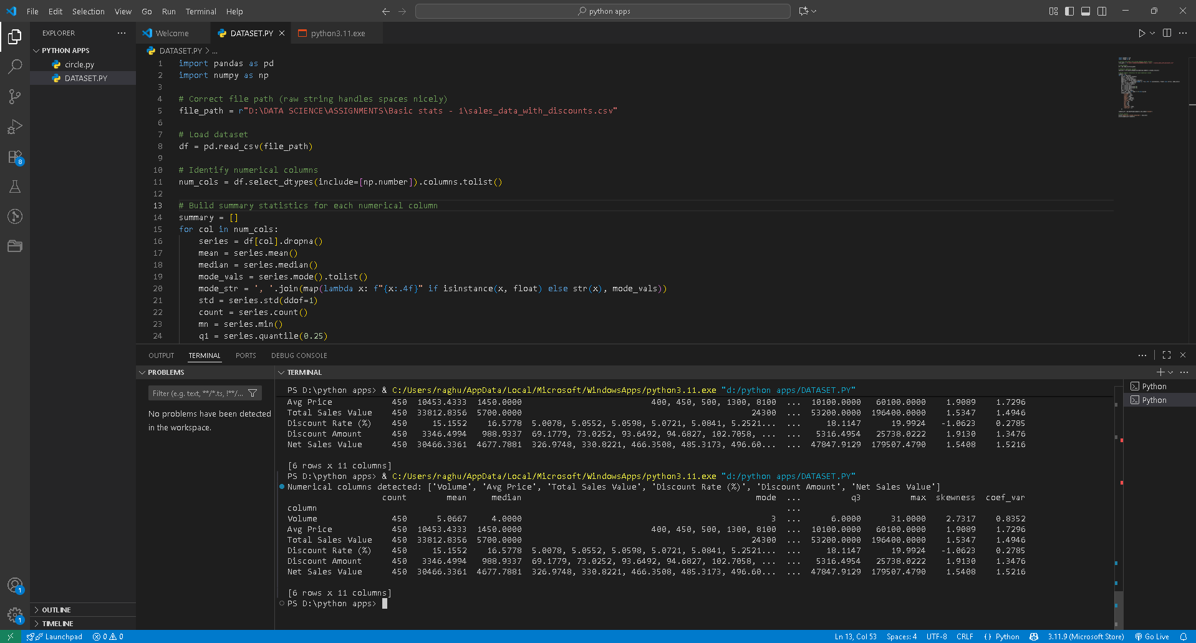

* 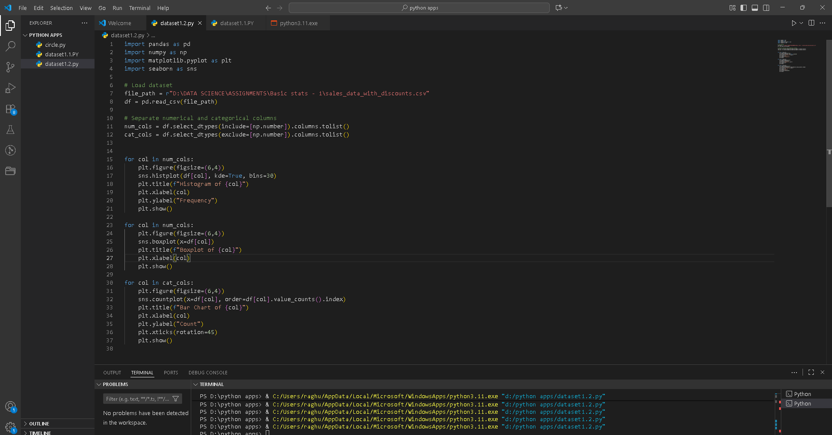**Objective**: To visualize the distribution and relationship of numerical and categorical variables in the dataset.

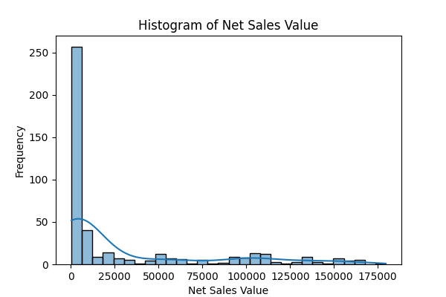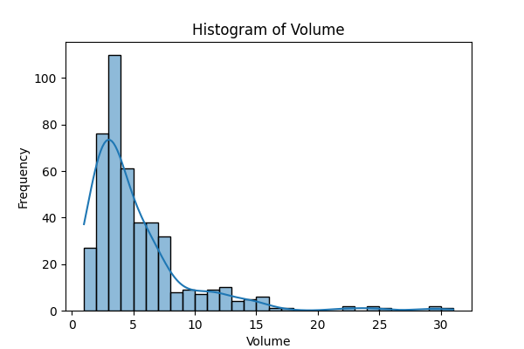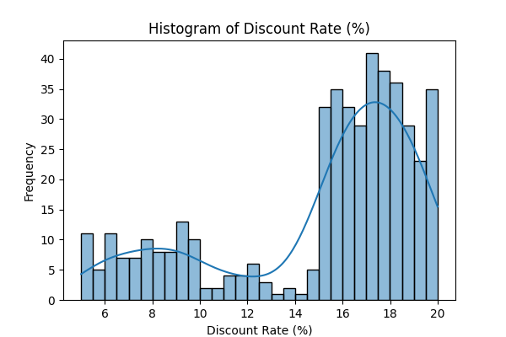**Histogram**

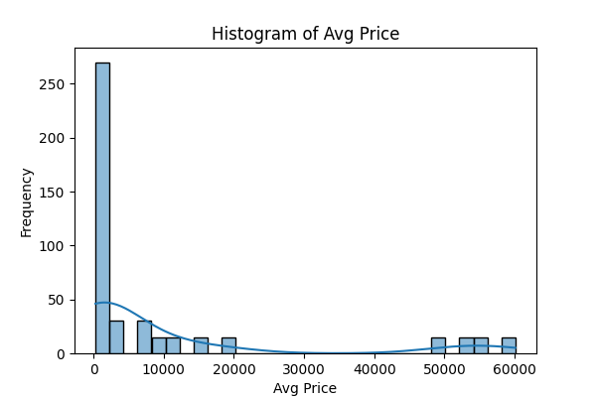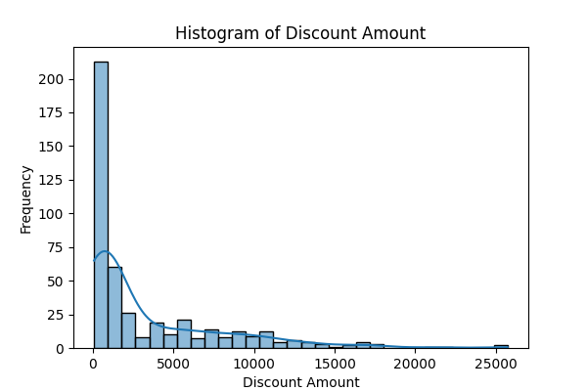

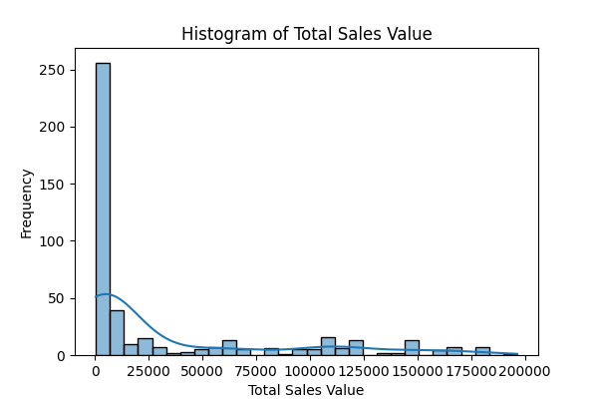

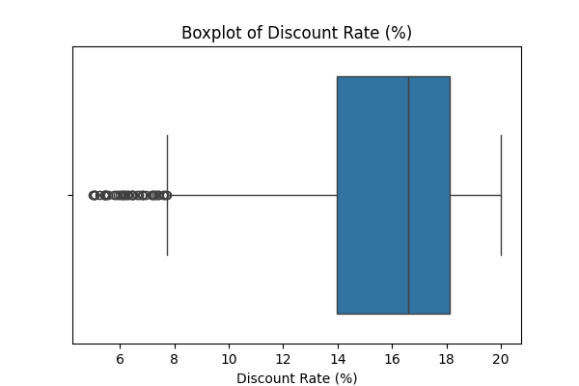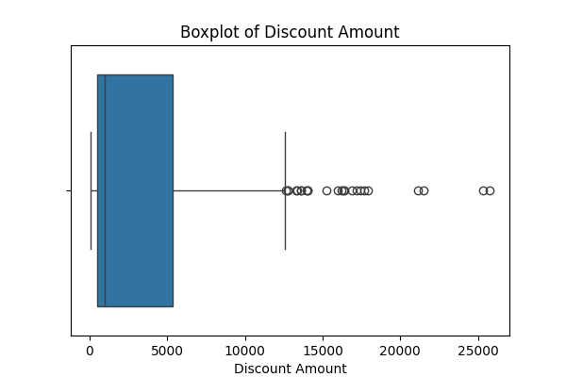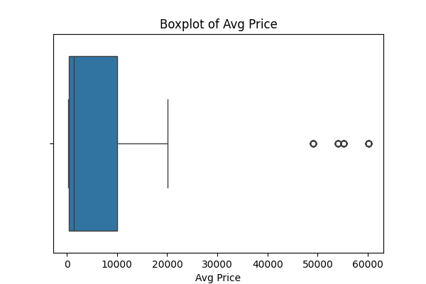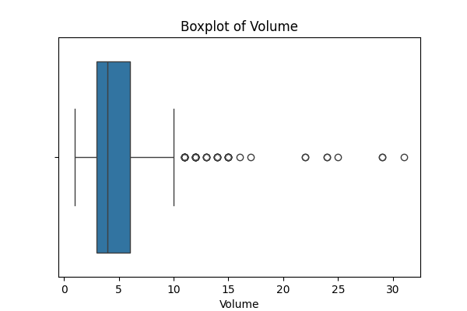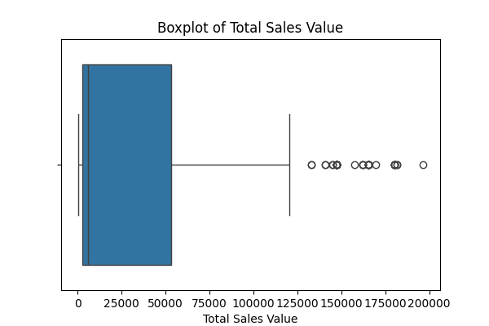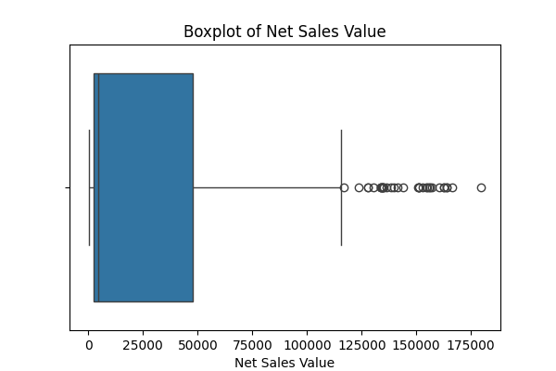**Boxplots**

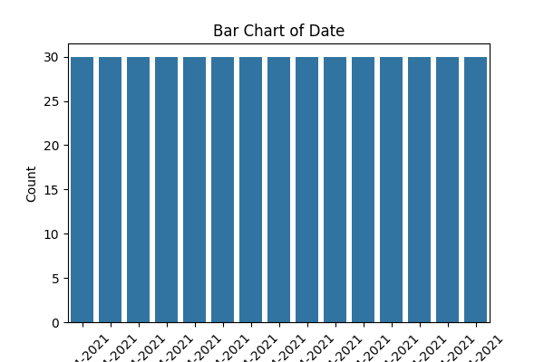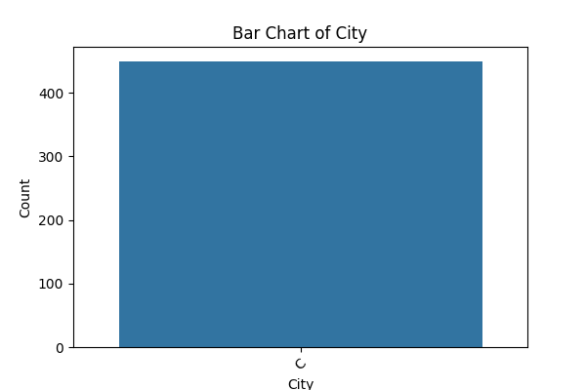**Barchart:**

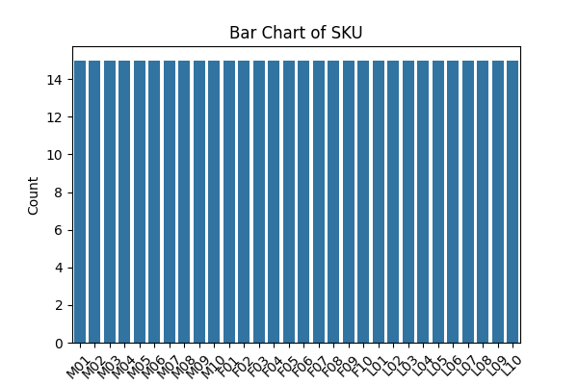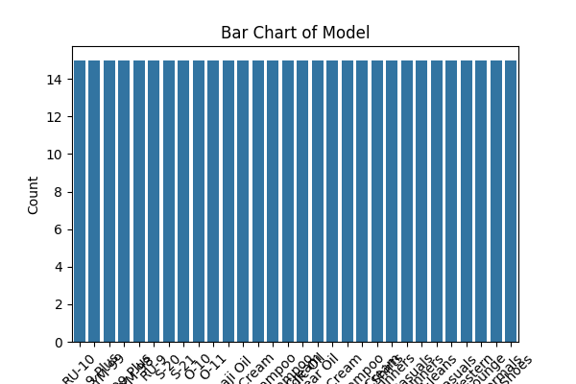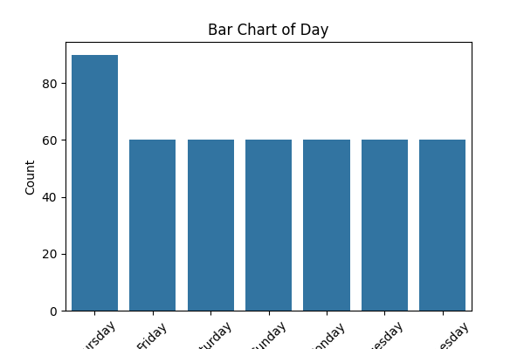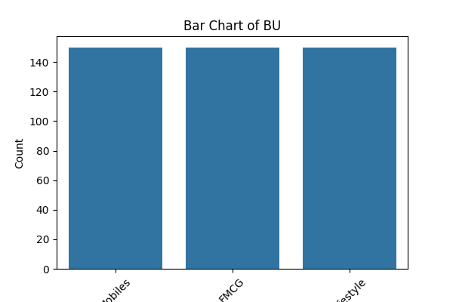

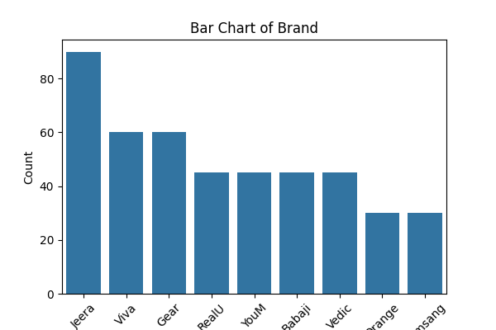

**Code executed:**

**import pandas as pd**

**import numpy as np**

**import matplotlib.pyplot as plt**

**import seaborn as sns**

**# Load dataset**

**file_path = r"D:\DATA SCIENCE\ASSIGNMENTS\Basic stats - 1\sales_data_with_discounts.csv"**

**df = pd.read_csv(file_path)**

**# Separate numerical and categorical columns**

**num_cols = df.select_dtypes(include=[np.number]).columns.tolist()**

**cat_cols = df.select_dtypes(exclude=[np.number]).columns.tolist()**

**for col in num_cols:**

**plt.figure(figsize=(6,4))**

**sns.histplot(df[col], kde=True, bins=30)**

**plt.title(f"Histogram of {col}")**

**plt.xlabel(col)**

**plt.ylabel("Frequency")**

**plt.show()**

**for col in num_cols:**

**plt.figure(figsize=(6,4))**

**sns.boxplot(x=df[col])**

**plt.title(f"Boxplot of {col}")**

**plt.xlabel(col)**

**plt.show()**

**for col in cat_cols:**

**plt.figure(figsize=(6,4))**

**sns.countplot(x=df[col], order=df[col].value_counts().index)**

**plt.title(f"Bar Chart of {col}")**

**plt.xlabel(col)**

**plt.ylabel("Count")**

**plt.xticks(rotation=45)**

**plt.show()**

**Standardization of Numerical Variables**

**●Objective: To scale numerical variables for uniformity, improving the dataset’s suitability for analytical models.**

**Standardization (also called z-score normalization) transforms numerical values so that they have:**

* **Mean (μ) = 0**
* **Standard Deviation (σ) = 1**

**The formula is:**

**z=x−μσz = \frac{x - \mu}{\sigma}z=σx−μ​**

**Where:**

* **xxx = original value**
* **μ\muμ = mean of the column**
* **σ\sigmaσ = standard deviation of the column**

**This ensures that variables with different units (e.g., Sales in dollars, Quantity in units, Discount as a percentage) are brought to the same scale.**

**Code executed:**

**from sklearn.preprocessing import StandardScaler**

**import matplotlib.pyplot as plt**

**# Copy the original numerical data for comparison**

**num_data_before = df[num_cols].copy()**

**# Apply standardization**

**scaler = StandardScaler()**

**df_standardized = df.copy()**

**df_standardized[num_cols] = scaler.fit_transform(df[num_cols])**

**# Compare distributions before and after**

**for col in num_cols:**

**fig, axes = plt.subplots(1, 2, figsize=(10, 4))**

**sns.histplot(num_data_before[col], kde=True, ax=axes[0], bins=30)**

**axes[0].set_title(f"Before Standardization - {col}")**

**sns.histplot(df_standardized[col], kde=True, ax=axes[1], bins=30)**

**axes[1].set_title(f"After Standardization - {col}")**

**plt.show()**

**Interpretation**

* **Before standardization, each variable had its own scale (e.g., Sales values were in hundreds/thousands, while Discount values were between 0 and 1).**
* **After standardization:**
  + **All variables are centered at 0 (mean ≈ 0).**
  + **The spread (variance) of each variable is now 1.**
* **The *shape* of the distribution (skewness, presence of outliers) remains the same, but the scale is uniform across all features.**
* **This process makes the dataset more suitable for algorithms sensitive to feature scaling (e.g., K-means clustering, PCA, logistic regression).**